NETWORK day 05

================================================

display current-configuration //查大部分配置

display version //查设备版本

display vlan //查vlan

display ip interface brief //查ip地址的配置情况

display ip routing-table //查看完整路由表

display ip routing-table | include /24 //过滤查看只包含24位掩码的

路由表

display this //查看当前视图的配置

display vrrp brief //查看vrrp摘要信息

display acl all //查所有acl

**组建大型企业网络**

**步骤一：为3700交换机修改主机名，配置vlan**

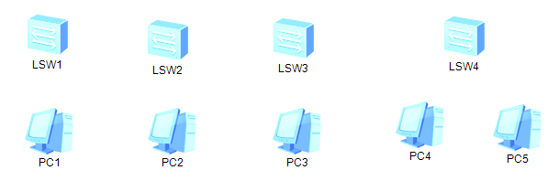

1，

[Huawei]sysname sw1 //依次将名称修改为sw1~sw4

[sw1]undo info-center enable //关闭日志

2，

[sw1]vlan batch 10 20 30 40 //依次在4台3700创建4个vlan

**步骤二：将终端设备加入对应的vlan**

1，

[sw1]in e0/0/1

[sw1-Ethernet0/0/1]port link-type access //配置为接入链路

[sw1-Ethernet0/0/1]port default vlan 10 //将1口加入vlan10

[sw2]in e0/0/1

[sw2-Ethernet0/0/1]port link-type access

[sw2-Ethernet0/0/1]port default vlan 20 //将1口加入vlan20

[sw3]in e0/0/1

[sw3-Ethernet0/0/1]port link-type access

[sw3-Ethernet0/0/1]port default vlan 30 //将1口加入vlan30

[sw4]in e0/0/1

[sw4-Ethernet0/0/1]port link-type access

[sw4-Ethernet0/0/1]port default vlan 40 //将1口加入vlan40

[sw4-Ethernet0/0/1]in e0/0/2

[sw4-Ethernet0/0/2]port link-type access

[sw4-Ethernet0/0/2]port default vlan 40 //将2口也加入vlan40

2, 为所有s3700的g0/0/1、g0/0/2口配置trunk

[sw1-Ethernet0/0/1]in g0/0/1 //常规手段一个一个接口配置

[sw1-GigabitEthernet0/0/1]port link-type trunk //配置中继链路

[sw1-GigabitEthernet0/0/1]port trunk allow-pass vlan all //放行所有

[sw1-GigabitEthernet0/0/1]in g0/0/2

[sw1-GigabitEthernet0/0/2]port link-type trunk

[sw1-GigabitEthernet0/0/2]port trunk allow-pass vlan all

[sw2]port-group 1 //或者使用接口组，创建1号接口组

[sw2-port-group-1]group-member GigabitEthernet 0/0/1

GigabitEthernet 0/0/2 //加成员是g1口与g2口

[sw2-port-group-1]port link-type trunk //也同样配置为中继链路

[sw2-port-group-1]port trunk allow-pass vlan all //放行所有

[sw3]port-group 1

[sw3-port-group-1]group-member GigabitEthernet 0/0/1 GigabitEthernet 0/0/2

[sw3-port-group-1]port link-type trunk

[sw3-port-group-1]port trunk allow-pass vlan all

[sw4]port-group 1

[sw4-port-group-1]group-member GigabitEthernet 0/0/1 GigabitEthernet 0/0/2

[sw4-port-group-1]port link-type trunk

[sw4-port-group-1]port trunk allow-pass vlan all

如果接口配置错误，可以使用以下方式恢复：

[sw1]clear configuration interface g0/0/1 //清空g0/0/1号接口的配

置，途中按y确认

[sw1]in g0/0/1 //再进入该接口

[sw1-GigabitEthernet0/0/1]undo shutdown //开启接口

**步骤三：添加两台s5700交换机，分别修改名称为sw5与sw6**

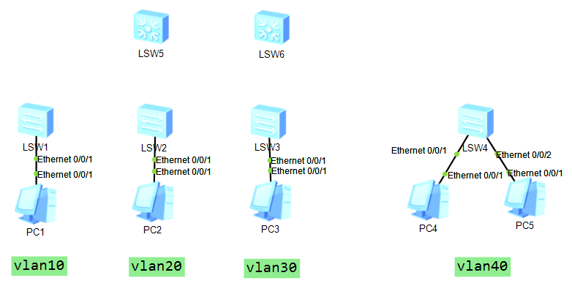

1，

[Huawei]sysname sw5 //该主机名

[sw5]undo info-center enable //关闭日志

2，

[sw5]vlan batch 10 20 30 40 //批量创建4个vlan

[sw6]vlan batch 10 20 30 40

**步骤四：为两台s5700连接了s3700的接口配置中继链路，**

1，配置两台s5700的中继链路

[sw5]port-group 1 //由于需要配置g1~g4口，这里使用接口组

[sw5-port-group-1]group-member GigabitEthernet 0/0/1 to

GigabitEthernet 0/0/4 //加g1~g4接口

[sw5-port-group-1]port link-type trunk //配置为中继链路

[sw5-port-group-1]port trunk allow-pass vlan all //放行所有

[sw6]port-group 1 //另外一台也是相同配置

[sw6-port-group-1]group-member GigabitEthernet 0/0/1 to

GigabitEthernet 0/0/4

[sw6-port-group-1]port link-type trunk

[sw6-port-group-1]port trunk allow-pass vlan all

2，将每台s5700的5口和6口捆绑成链路聚合，并配置中继链路

[sw5]interface Eth-Trunk 1 //创建(进入)链路聚合接口

[sw5-Eth-Trunk1]trunkport GigabitEthernet 0/0/5 0/0/6 //捆绑5口

与6口

[sw5-Eth-Trunk1]port link-type trunk //配置成中继链路

[sw5-Eth-Trunk1]port trunk allow-pass vlan all //放行所有

[sw6]interface Eth-Trunk 1 //sw6的配置一样

[sw6-Eth-Trunk1]trunkport GigabitEthernet 0/0/5 0/0/6

[sw6-Eth-Trunk1]port link-type trunk

[sw6-Eth-Trunk1]port trunk allow-pass vlan all

**步骤五：为s5700配置ip地址**

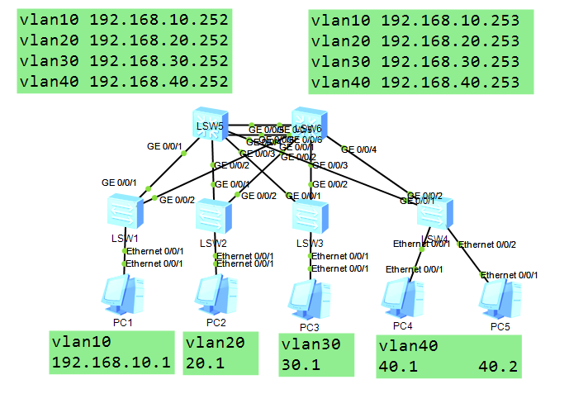

1，s5700的vlan配置不同ip

[sw5]in vlan 10

[sw5-Vlanif10]ip add 192.168.10.252 24

[sw5-Vlanif10]in vlan 20

[sw5-Vlanif20]ip add 192.168.20.252 24

[sw5-Vlanif20]in vlan 30

[sw5-Vlanif30]ip add 192.168.30.252 24

[sw5-Vlanif30]in vlan 40

[sw5-Vlanif40]ip add 192.168.40.252 24

[sw6]in vlan 10

[sw6-Vlanif10]ip add 192.168.10.253 24

[sw6-Vlanif10]in vlan 20

[sw6-Vlanif20]ip add 192.168.20.253 24

[sw6-Vlanif20]in vlan 30

[sw6-Vlanif30]ip add 192.168.30.253 24

[sw6-Vlanif30]in vlan 40

[sw6-Vlanif40]ip add 192.168.40.253 24

然后依次为pc配置ip

10.1 20.1 30.1 40.1 40.2

目前可以实现全同网段互通，如果不同，检查：

1. ip地址
2. 是否所有交换机创建所有vlan
3. pc连接交换机接口的链路是否加入到对应vlan，交换

机与交换机之间的链路是否为trunk

sw5 vlan10、20主 vlan30、40备

sw6 vlan30、40主 vlan10、20备

[sw5]in vlan 10 //进入vlan10接口

[sw5-Vlanif10]vrrp vrid 10 virtual-ip 192.168.10.254 //开启vrrp

并配置虚拟路由器ip是10.254

[sw5-Vlanif10]vrrp vrid 10 priority 105 //修改优先级为105

[sw5-Vlanif10]in vlan 20

[sw5-Vlanif20]vrrp vrid 20 virtual-ip 192.168.20.254

[sw5-Vlanif20]vrrp vrid 20 priority 105

[sw5-Vlanif20]in vlan 30

[sw5-Vlanif30]vrrp vrid 30 virtual-ip 192.168.30.254

[sw5-Vlanif30]in vlan 40

[sw5-Vlanif40]vrrp vrid 40 virtual-ip 192.168.40.254

[sw6]in vlan 10

[sw6-Vlanif10]vrrp vrid 10 virtual-ip 192.168.10.254

[sw6-Vlanif10]in vlan 20

[sw6-Vlanif20]vrrp vrid 20 virtual-ip 192.168.20.254

[sw6-Vlanif20]in vlan 30

[sw6-Vlanif30]vrrp vrid 30 virtual-ip 192.168.30.254

[sw6-Vlanif30]vrrp vrid 30 priority 105 //sw6要成为vlan30的主，所以

要修改优先级

[sw6-Vlanif30]in vlan 40

[sw6-Vlanif40]vrrp vrid 40 virtual-ip 192.168.40.254

[sw6-Vlanif40]vrrp vrid 40 priority 105 //sw6要成为vlan40的主，所以

要修改优先级

<sw5>display vrrp brief //vrrp配置好之后检查每台三层交换机应该是

两主两备的状态

将所有pc的网关按照所在vlan配置好对应的虚拟路由器的ip，并测试全网互通效果

1，

[Huawei]sysname r1 //改名

[r1]in g0/0/0 //进入0接口

[r1-GigabitEthernet0/0/0]ip add 192.168.50.1 24 //配置ip

[sw5]vlan 50 //创建vlan50

[sw5-vlan50]in vlan 50 //进入vlan50

[sw5-Vlanif50]ip add 192.168.50.2 24 //配置ip

[sw5-Vlanif50]in g0/0/7 //进入7口

[sw5-GigabitEthernet0/0/7]port link-type access

[sw5-GigabitEthernet0/0/7]port default vlan 50 //加入vlan50

<sw5>display ip interface brief //查看ip配置情况

其他ip按上图配置，此处省略

**步骤八：在所有路由器以及s5700配置动态路由**

1，

[sw5]ospf //开启动态路由协议ospf

[sw5-ospf-1]area 0 //进入区域0

[sw5-ospf-1-area-0.0.0.0]network 192.168.10.0 0.0.0.255 //宣告

直连网段

[sw5-ospf-1-area-0.0.0.0]network 192.168.20.0 0.0.0.255

[sw5-ospf-1-area-0.0.0.0]network 192.168.30.0 0.0.0.255

[sw5-ospf-1-area-0.0.0.0]network 192.168.40.0 0.0.0.255

[sw5-ospf-1-area-0.0.0.0]network 192.168.50.0 0.0.0.255

[sw5-ospf-1-area-0.0.0.0]network 192.168.70.0 0.0.0.255

[sw6]ospf

[sw6-ospf-1]area 0

[sw6-ospf-1-area-0.0.0.0]network 192.168.10.0 0.0.0.255

[sw6-ospf-1-area-0.0.0.0]network 192.168.20.0 0.0.0.255

[sw6-ospf-1-area-0.0.0.0]network 192.168.30.0 0.0.0.255

[sw6-ospf-1-area-0.0.0.0]network 192.168.40.0 0.0.0.255

[sw6-ospf-1-area-0.0.0.0]network 192.168.60.0 0.0.0.255

[sw6-ospf-1-area-0.0.0.0]network 192.168.80.0 0.0.0.255

[r1]ospf //然后在两台路由器上也配置ospf

[r1-ospf-1]area 0

[r1-ospf-1-area-0.0.0.0]network 192.168.50.0 0.0.0.255

[r1-ospf-1-area-0.0.0.0]network 192.168.60.0 0.0.0.255

[r2]ospf

[r2-ospf-1]area 0

[r2-ospf-1-area-0.0.0.0]network 192.168.70.0 0.0.0.255

[r2-ospf-1-area-0.0.0.0]network 192.168.80.0 0.0.0.255

然后测试全网互通的效果

dis ip routing-table | include /24 //检查路由表